BrightLink 575Wi Interactive WXGA 3LCD Projector

Q: | The cursor location and pen position do not match. It is difficult to join lines, annotate, or select objects. What is Wrong?
A: | For best pen accuracy, Epson recommends calibrating the pens manually. Follow these steps:  Calibrating Manually  If the cursor location and pen position do not match after auto calibration, you can calibrate manually.  - Press the Menu button, select the Extended menu, and pressEnter.  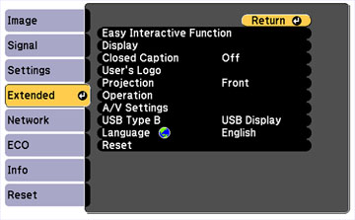  - Select the Easy Interactive Function setting and press Enter.  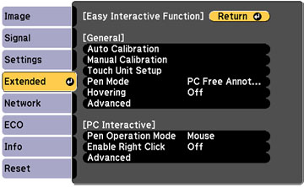  - Select Manual Calibration and press Enter.  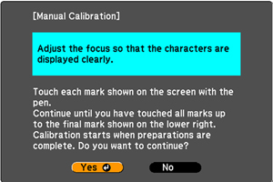  - Adjust the image focus if necessary.  - Press Enter to select Yes. A flashing green circle appears in the upper left corner of your projected image.  - Touch the center of the circle with the tip of the pen. The circle disappears, and you see another circle below the first one.  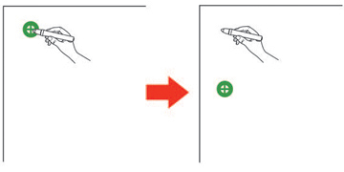  Note: For the most accurate calibration, make sure you touch the center of the circle.  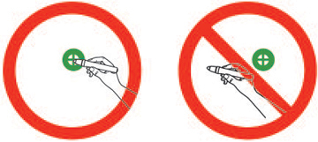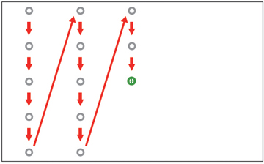  - Touch the center of the next circle, then repeat. When you get to the bottom of the column, the next circle appears at the top of a new column.  Note: Make sure you are not blocking the signal between the pen and the interactive receiver (next to the projection window on the projector).  If you make a mistake, press the Esc button on the remote control to go back to the previous circle. To restart the calibration process, press and hold the Esc button for 2 seconds.  - Continue until all of the circles disappear.

